**Atlas Lab HR Analysis in Power BI**

**Abstract**

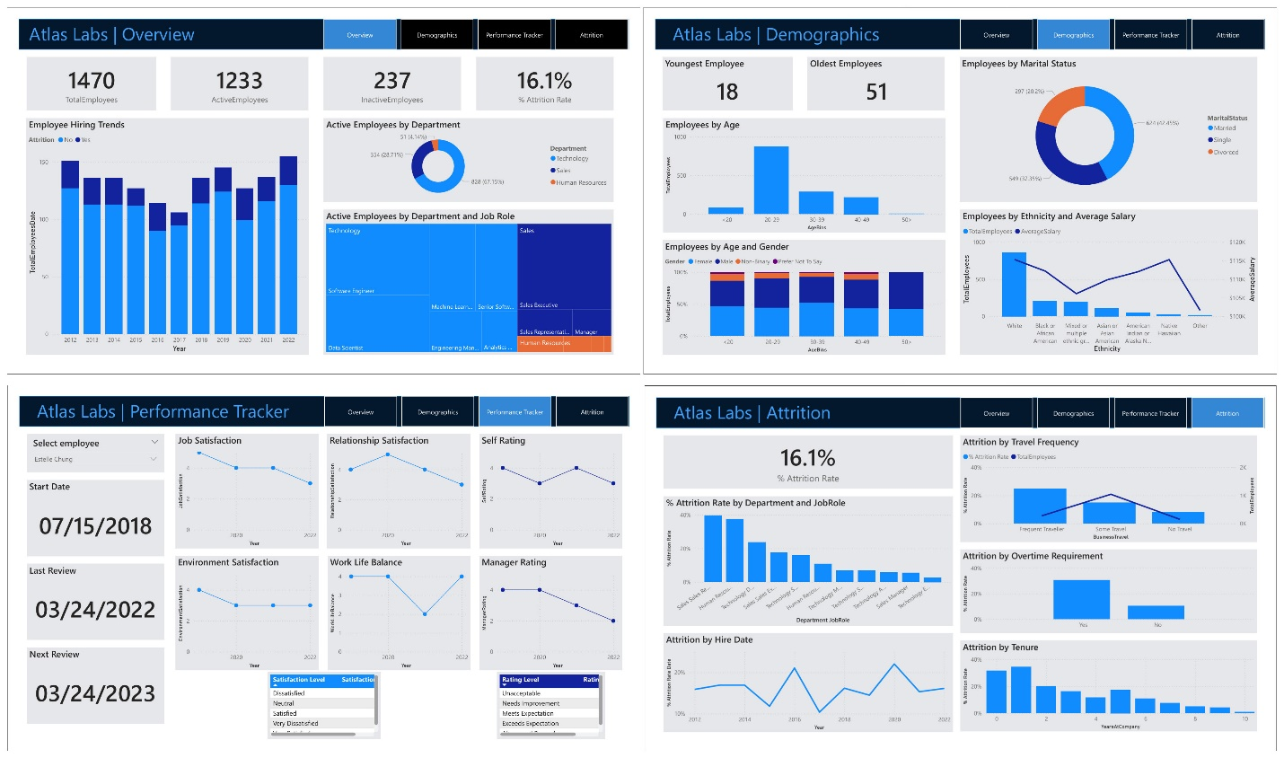

**Introduction**

The workforce is the most critical asset of any organization, and data-driven HR practices have become essential for optimizing employee performance, improving retention, and ensuring equitable talent development. This HR analytics project utilizes Power BI to transform raw employee data into actionable insights, covering key themes such as headcount, attrition, demographics, satisfaction, and performance. By visualizing trends across departments, roles, and time, the report equips HR leaders and decision-makers with the knowledge needed to align workforce strategy with organizational goals.

**Problem Statement**

Despite having access to HR data, many organizations struggle to translate that data into meaningful insights that drive business value. Without a unified view of key workforce metrics, it becomes difficult to proactively identify turnover risks, manage diversity and inclusion, track employee engagement, or plan future hiring needs effectively. This can result in high attrition, resource misalignment, or stalled talent development initiatives.

**Objectives**

The objective of this project is to analyze and interpret employee data to uncover patterns, identify areas of concern, and support strategic HR decision-making. Specifically, the analysis aims to:

* Monitor workforce composition and headcount trends
* Evaluate attrition drivers across departments, tenure, and roles
* Assess satisfaction and performance indicators to guide retention strategies
* Support diversity, equity, and inclusion (DEI) initiatives through demographic analysis
* Provide actionable recommendations to improve employee experience and optimize HR operations

**Potential Questions**

* Which departments have the most active employees?
* How are job roles distributed within each department?
* How has the hiring volume changed over the years?
* What is the age distribution of the workforce?
* How is gender represented across different age groups?
* What is the breakdown of marital status in the organization?
* How are ethnic groups represented, and what is their average salary?
* How do employee satisfaction levels vary across different dimensions (job, environment manager, etc.)? and how have satisfaction metrics changed over time?
* Which departments and job roles have the highest attrition rates?
* How does travel frequency relate to employee turnover?
* Are employees who work overtime more likely to leave?
* How does attrition vary by employee tenure?
* Has attrition increased or decreased over recent years?

**Data Source**

The Atlas Lab HR Analytics dataset was gotten from datacamp.

**Data Description**

**Educational Level Table**

* Educational Level
* Educational Level ID

**Rating Level Table**

* Rating ID
* Rating Level

**Satisfied Level Table**

* Satisfaction ID
* Satisfaction Level

**Employees**

* Age
* Age bins
* Attrition
* Business travel
* Department
* Distance from home
* Education
* Education field
* Employee ID
* Ethnicity
* First name
* Full name
* Gender
* Hire date
* Job role
* Last name
* Marital status
* Over time
* Salary
* State
* Stock option level
* Year at company
* Year in most recent role
* Year since last promotion
* Year with current manager

**Performance Rating**

* Employee ID
* Environment satisfaction
* Job satisfaction
* Manager rating
* Performance ID
* Relationship satisfaction
* Review date
* Self-rating
* Training opportunities taken
* Training opportunities within year
* Work life balance

Also, there is a date table and some measures were calculated’

**Data Cleaning and Transformation**

The dataset was cleaned blanks and duplicates were removed and calculated measures were created.

**Statistical Analysis**

**KPI Cards**

The KPI cards were created by going to the visualization pane and selecting cards and then selecting the column from the table used for the kpi cards and they were from the employees table and the measures

**Referencing KPI Cards with dashboard**



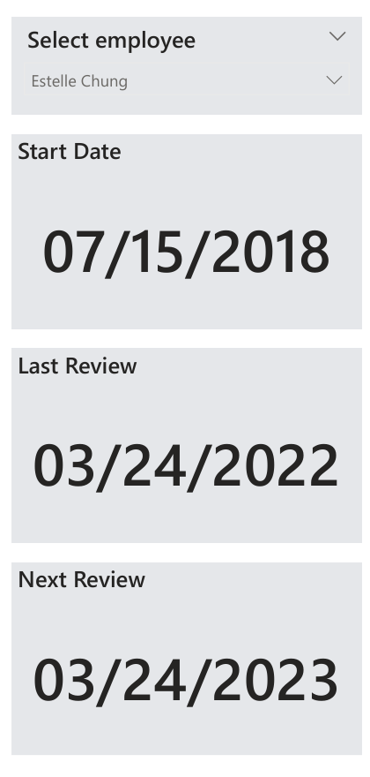

**Analysis**

**Overview Page**

**Analysis Questions**

* Which departments have the most active employees?
* How are job roles distributed within each department?
* How has the hiring volume changed over the years?

**Approach to answering the question**

* **Employee Hiring Trend**

I added stacked column chart from the visualization pane and put date from the date table to X axis and employee dates set in total to Y axis and attrition as legend from the employee table.

* **Active employees by department**

I added doughnut chart from the visualization pain and then I put active employee from the calculated measures to values and departments as legends from the employee table

* **Active employee by department and job role**

I added tree map visual from the visualization form and I added departments to category from and I added job role to details from the employees table then I added active employees to values from the calculated measure.

**Insights**

* Hiring volume has been inconsistent across the years, showing peaks in some periods and dips in others, suggesting reactive rather than strategic hiring practices.
* The Technology department holds many active staff, followed by Sales. HR has significantly fewer staff across all roles.
* The Sales Executive role (269) and Software Engineer role (247) are the most populated. HR roles are notably lean (e.g., Recruiters = 15).

**Demographic Page**

**Analysis Questions**

* What is the age distribution of the workforce?
* How is gender represented across different age groups?
* What is the breakdown of marital status in the organization?
* How are ethnic groups represented, and what is their average salary?

**Approach to answering the question**

* **Employee by age**

I added stacked column charts from the visualization pane and I added age bins to X axis from the employee table and total employee in the Y axis from the calculated measure

* **Employee by Marital Status**

I added doughnut chart from the visualization pane and I added marital status as the legend from the employee table and total employees to values from the calculated measure

* **Employee by age and gender**

I added stacked column charts to from the visualization pane and then I added age bin from the employee table to the X axis, total employee from the calculated measure to the Y axis and gender also from the employee table to the legend.

* **Employee by ethnicity and average salary**

I added line and stacked column charts from the visualization pane and then I added ethnicity to the X axis from the employee table, total employee in the Y axis and average salary to the line Y axis from the calculated measure

**Insights**

* Employees aged 20–29 dominate the workforce (874), followed by 30–39. Only 7 employees are over 50.
* Many employees are married (42.45%), followed by singles and divorced.
* White employees form the majority, followed by Black or African Americans. Ethnic minorities such as Native Hawaiian and “Other” have minimal representation. Average salaries vary across groups.
* The workforce is heavily concentrated in the 20–29 age group, with imbalanced gender representation in older age brackets. This may indicate limited age diversity and unequal advancement.

**Performance Tracker Page**

**Analysis Questions**

* How do employee satisfaction levels vary across different dimensions (job, environment, manager, etc.)? and how have satisfaction metrics changed over time?
* What trends exist in manager ratings versus self-ratings?

**Approach to answering the question**

* **Job Satisfaction**

A line chart from the visualization pane was added and year from the date from the date table was added to the x axis and job satisfaction was added to the y axis from the calculated measure.

* **Relationship Satisfaction**

A line chart from the visualization pane was added and year from the date from the date table was added to the x axis and relationship satisfaction was added to the y axis from the calculated measure

* **Self-Rating**

A line chart from the visualization pane was added and year from the date from the date table was added to the x axis and self-rating was added to the y axis from the calculated measure

* **Environment Satisfaction**

A line chart from the visualization pane was added and year from the date from the date table was added to the x axis and environment satisfaction was added to the y axis from the calculated measure

* **Work Life Balance**

A line chart from the visualization pane was added and year from the date from the date table was added to the x axis and work life balance was added to the y axis from the calculated measure

* **Manager Rating**

A line chart from the visualization pane was added and year from the date from the date table was added to the x axis and manager rating was added to the y axis from the calculated measure

**Insights**

* Job satisfaction has shown a declining trend in recent years.
* Relationship satisfaction improved in 2020 but declined in 2021 and 2022.
* Employee self-ratings have fluctuated (4→3→4→3 from 2019–2022).
* Environmental satisfaction has steadily decreased.
* Work-life balance dipped in 2021 and recovered slightly in 2022.
* Manager ratings remained steady in 2019–2020 but declined afterward.

**ATTRITION PAGE**

**Analysis Questions**

* Which departments and job roles have the highest attrition rates?
* How does travel frequency relate to employee turnover?
* Are employees who work overtime more likely to leave?
* How does attrition vary by employee tenure?
* Has attrition increased or decreased over recent years?

**Approach to answering the question**

* **Attrition by travel frequency**

I added a line and stacked column chart from the visualization pane, and I added business travel from the employee table to the x axis and %attrition rates to the Y axis and total employee to the line y axis from the calculated measure.

* **Attrition by overtime requirement**

I added a stacked column chart from the visualization pane, and I added over time from the employee table to the x axis and %attrition rate from the calculated measure was added to the y axis.

* **Attrition by tenure**

I added a stacked column chart from the visualization pane, and I added year at company from the employee table to the x axis and %attrition rate from the calculated measure was added to the y axis.

* **%Attrition Rate by Department and Job role**

I added a stacked column chart from the visualization pane, and I added department and job role from the employee table to the x axis and %attrition rate from the calculated measure was added to the y axis.

* **Attrition by Hire Date**

I added a line chart from the visualization pane, and I added date from the date table to the x axis and %attrition rate from the calculated measure was added to the y axis.

**Insights**

* High attrition is seen among Sales Reps, Recruiters, and Data Scientists. Conversely, roles like Engineering Managers and Sales Managers have low attrition.
* Employees hired in 2013, 2014, 2016, 2018, and 2020 have higher attrition rates.
* Employees are most likely to leave within their first year, then attrition gradually declines with tenure.
* Frequent travelers show the highest attrition rate, though “some travel” has the highest headcount.

**Visualization**



**INTERPRETATION OF RESULTS**

* The organization has experienced inconsistent hiring patterns, suggesting that recruitment efforts may be driven by short-term needs rather than long-term workforce planning.
* The Technology and Sales departments dominate the headcount, indicating these are core business units. In contrast, HR is significantly under-resourced, potentially limiting its ability to support employee experience, talent development, and retention strategies.
* A disproportionate number of employees fall within the 20–29 age bracket, suggesting a young and early-career-heavy workforce. The low representation of employees over 50 may signal challenges in retaining experienced talent or in creating an inclusive environment for older professionals.
* Married employees represent the largest group, implying the workforce may benefit from benefits and policies that support family needs.
* White employees make up the majority, followed by Black or African American staff, while other ethnic groups have minimal representation. This reflects potential gaps in ethnic diversity and inclusion, especially when paired with salary variances across groups.
* Gender representation is relatively balanced in younger age groups but becomes uneven in older age brackets, pointing to possible inequities in advancement opportunities or retention of diverse talent over time**.**
* Job satisfaction, environmental satisfaction, and manager ratings have all declined, especially post-2020, suggesting that workplace engagement and leadership effectiveness may be deteriorating.
* Relationship satisfaction improved in 2020, possibly due to increased support or team cohesion during early remote work, but dropped again afterward, indicating a need to strengthen workplace relationships in a hybrid/remote context.
* Self-ratings have fluctuated, possibly reflecting inconsistent role expectations, unclear goals, or ineffective feedback systems.
* Although work-life balance recovered slightly in 2022, the dip in 2021 highlights continued pressure or burnout in specific areas.
* High attrition among Sales Reps, Recruiters, and Data Scientists suggests these roles may have demanding workloads, limited growth opportunities, or insufficient support.
* Employees hired in specific years (2013, 2014, 2016, 2018, 2020) show higher attrition, potentially due to weak onboarding or cultural misalignment during those periods.
* Attrition is highest within the first year, confirming the vulnerability of new hires and pointing to onboarding or early engagement issues.
* Frequent travelers experience the highest attrition, indicating a link between extensive business travel and burnout or job dissatisfaction.

**Recommendation**

* **Reinforce Workforce Stability Through Predictive Planning**  
  Implement a proactive, data-driven workforce planning framework that integrates hiring forecasts, attrition patterns, and growth projections. This ensures staffing is aligned with strategic goals and reduces reactionary hiring that strains resources.
* **Establish a Turnover Early-Warning System**  
  Introduce quarterly pulse surveys and structured exit interviews to identify root causes of voluntary exits. Use attrition heatmaps to pinpoint high-risk roles or cohorts and deploy tailored retention interventions.
* **Recalibrate HR Capacity for Strategic Enablement**  
  Evaluate the bandwidth of HR sub-functions. Given the low staffing in critical roles (e.g., only 4 HR Managers), consider investing in HR technology (e.g., automated onboarding, digital case management) or hiring for strategic business partnering capabilities.
* **Link Headcount to Impact with Role-Specific KPIs**  
  Develop and track performance metrics by job function especially in high-volume roles like Sales Executives and Software Engineers to ensure workforce size correlates with value contribution and operational efficiency.
* **Create Retention Pipelines for Early-Career Talent**  
  Design structured development programs for employees aged 20–29, including mentorship pairings, growth roadmaps, and cross-functional rotations to increase engagement, reduce attrition, and prepare future leaders.
* **Offer Life-Stage-Aligned Benefits**  
  Expand benefits packages to support employees across personal milestones. Include on-site childcare, remote work options, caregiver leave, and health wellness stipends to improve retention of mid-career and family-focused employees.
* **Embed Equity into Compensation and Mobility Practices**  
  Conduct a comprehensive pay equity audit and enhance your DEI strategy with intentional recruitment, promotion, and sponsorship pathways for underrepresented groups ensuring equitable access to opportunities.
* **Diversify Leadership Through Intentional Succession Planning**  
  Establish inclusive leadership programs that support high-potential talent from all age groups and gender identities. This promotes upward mobility and addresses representation gaps at senior levels.
* **Modernize Performance and Feedback Systems**  
  Address inconsistencies in satisfaction and self-ratings by streamlining performance reviews. Embed continuous feedback mechanisms and define clear success metrics to improve accountability and employee confidence.
* **Invest in Managerial Capability and Trust Building**  
  Deploy 360° feedback cycles and enroll managers in leadership coaching that emphasizes empathy, communication, and psychological safety. Regularly measure team-level engagement as a proxy for management effectiveness.
* **Foster a Culture of Listening and Psychological Safety**Audit work environments for burnout risks. Use anonymous digital suggestion tools and feedback loops to continuously capture and act on employee concerns related to workload, tools, and team culture.
* **Normalize Flexibility as a Business Strategy**  
  Institutionalize flexible scheduling and hybrid work policies, especially in departments with high intensity or travel demands. Encourage leaders to model work-life balance visibly.
* **Design Onboarding to Reduce First-Year Attrition**  
  Re-engineer the onboarding experience with structured 30/60/90-day milestones, buddy systems, and manager check-ins to increase connection and reduce early exits — especially for new hires in at-risk roles.
* **Address Historical Gaps in Hiring Cohorts**  
  Analyze training, onboarding, and leadership support for employees hired during high-attrition years (e.g., 2016, 2020). Use this to recalibrate practices for future cohorts and re-engage those at mid-tenure risk.
* **Develop Role-Specific Retention Levers**  
  For high-churn positions (e.g., Sales Reps, Recruiters), create tailored retention packages such as milestone-based bonuses, growth pathways, or reduced administrative overhead to improve job satisfaction.
* **Reduce Burnout Risk Among Frequent Travelers**Optimize business travel by incorporating fatigue management protocols, wellness allowances, and remote work flexibility. Ensure frequent travelers have recovery time and recognition for the intensity of their roles.

**Conclusion**

The HR analytics dashboard has provided valuable insights into hiring behavior and workforce demographics. The organization must shift from reactive to strategic hiring by aligning recruitment with projected business needs. Simultaneously, improving age and gender diversity—especially in senior roles can strengthen talent retention and promote a more inclusive, resilient workforce. By acting on these insights, the company can build a more balanced talent pipeline, reduce turnover, and foster long-term employee engagement and growth.